CS 4405: Mobile Applications
Learning Journal: Unit 7
Instructor: Rupa Sarda
Day of Submission: 2025/12/18

Question of Assignment
This assignment will assess your skills and knowledge in explaining the use of Swift generics and exception handling while making a connection to the internet in an iOS app.
Scenario: After the return to the office following the COVID-19 pandemic, the administration of your office has raised concerns about how employees will record their attendance without using the biometric machine, given the risk of physical contact. You've been tasked with developing a biometric attendance application for iOS using Swift. This application should allow employees to mark their attendance using the biometric recognition features on their smartphones, whether it's fingerprint, retina, or facial recognition, eliminating the need to touch the biometric machine.
Assumption: All employees have iPhone/iPad/iPod touch devices equipped with biometric recognition sensors/components.
- Project tasks in detail:
- Create a signup screen, where you will have some text fields for getting data from the user, like name and email.
- Integrate email validations. The user should be able to proceed further only if the entered email ID is valid; you should give an appropriate error message on the screen.
- Create the next screen such that the user can set up his/her password.
- Store data in the database after successful sign-up.
- Show the sign-in screen to the user with two text fields to get the mail ID and password.
If the credentials entered by the user match the ones he had given at signup, then they should be able to log in. Otherwise, show an error message on the screen. After successful sign-in, the user should land on the home screen of the app. On the home screen, add two buttons: 1 to check in, and 2 to check out.
Handle the following error cases:
- If there is no internet.
- If there is no data returned from the server; instead, it returns an error.
For check-in and checkout:
Case 1: If the user has not registered his/her biometric, you need to show an alert asking the user to register their biometric with the app. When the biometric is registered successfully, show a message that the biometric is registered successfully and save the biometric in the database.
Case 2: If the biometric is already registered, you must ask for it and match it with the ones saved in the database when the user provides it.
- If the biometric entered matches the ones saved in the database, then check if the user is on office premises by matching the GPS location of his mobile phone with the office location. If the location matches, then you can let them check-in/out, otherwise, show an appropriate error message. You also need to save the date and time for every successful check-in/out.
- If biometrics do not match, then show an appropriate message to the user.
Case 3: If the user has already checked in/out for the day, they should not be able to check-in/out again and you need to give a proper message to the user in this case.
Instructions:
- Create the app, test it on your iOS device or emulator/simulator, and take screenshots of all the screens, functionalities, and cases.
- Also, explain the error handling approach you have used in the app.
- You may use this dummy API to get sample data: JSONPlaceholder
Hint:
- Create a single-screen app, with a button on it that may be titled ‘fetch data’.
- With the tap of the button, you will be making the internet connection and will be calling the dummy API given above.
Handle the following cases using Swift’s error handling concept:
- When there is no internet connection.
- When there is no data fetched from the internet.

Biometric Attendance App
Signup Screen with email validation as well as password setup screen:
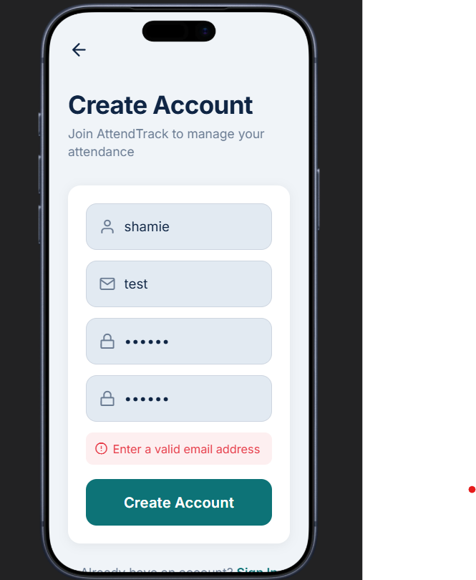

Sign in Screen:
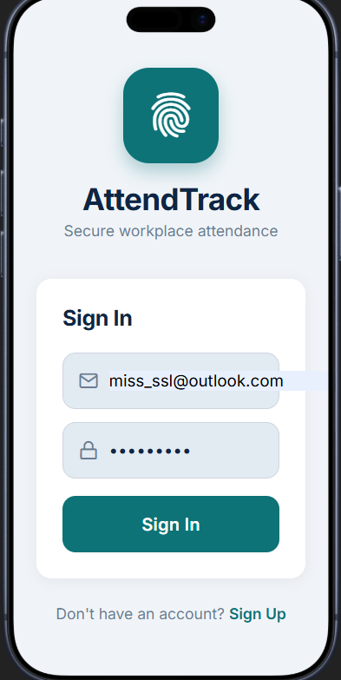
Sign-in screen showing failure (for using the wrong credentials):
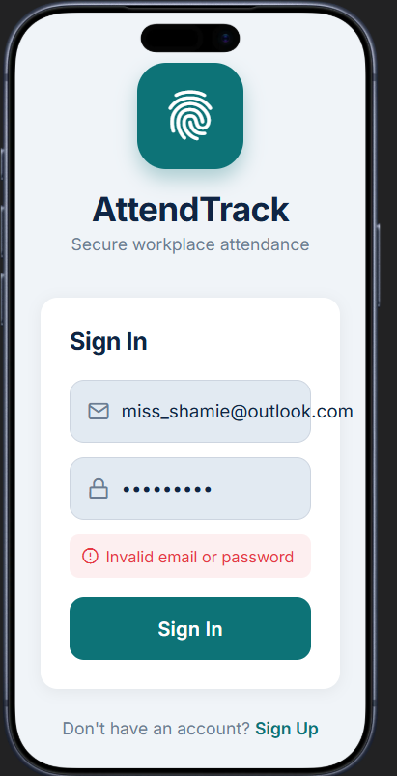

Home screen with check-in/check-out buttons
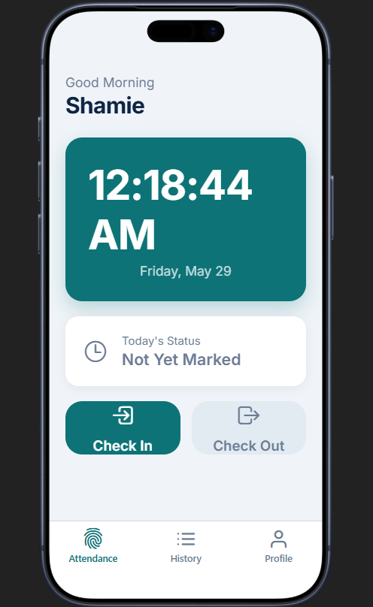

Biometric showing not registered (using LocalAuntentication)
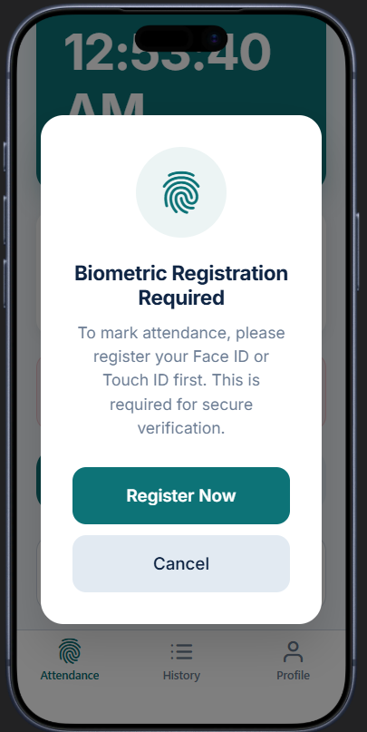

Biometric registered successfully (using CoreLocation):
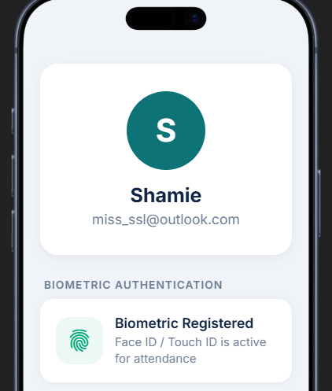

Check-in/out with timestamp, including notification for “checked in today”
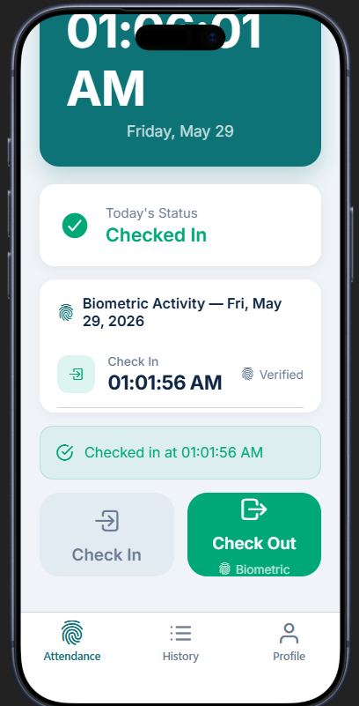

View attendance, previous check-in/out record(s)
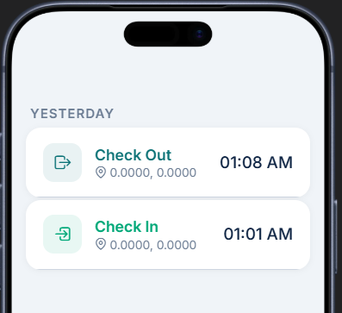

Location checking:
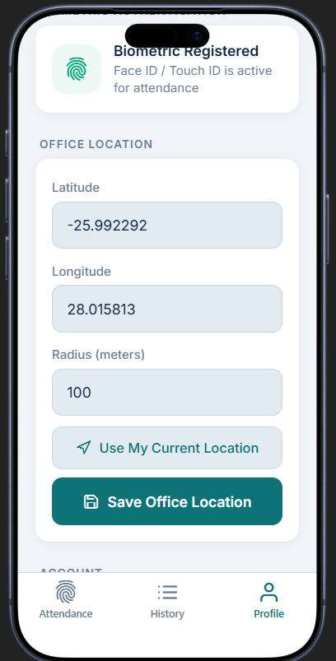

Network Error Handling:
Code:
import Foundation

// MARK: - Error Enum (Required by assignment)
enum NetworkError: Error {
case noInternet
case noData
case invalidResponse
case decodingFailed
case unknown(String)
}

// MARK: - Todo Model
struct Todo: Codable {
let userId: Int
let id: Int
let title: String
let completed: Bool
}

// MARK: - Network Manager with Complete Error Handling
class NetworkManager {

// This function simulates a network call but demonstrates REAL error handling
func fetchTodos(completion: @escaping (Result<[Todo], NetworkError>) -> Void) {

// SIMULATION MODE: Since online compilers don't support URLSession,
// we'll simulate different scenarios to demonstrate error handling.
// In a real iOS app, this would be an actual network request.

let simulationScenario = "success" // CHANGE THIS to test different errors
// Options: "success", "noInternet", "noData", "invalidResponse", "decodingFailed"

// Simulate network delay (like real async request)
DispatchQueue.global().asyncAfter(deadline: .now() + 1.0) {

switch simulationScenario {

// CASE 1: Successful response
case "success":
let sampleJSON = """
[
{"userId": 1, "id": 1, "title": "Buy groceries", "completed": false},
{"userId": 1, "id": 2, "title": "Walk the dog", "completed": true},
{"userId": 1, "id": 3, "title": "Study Swift", "completed": false},
{"userId": 1, "id": 4, "title": "Workout", "completed": true}
]
"""
guard let jsonData = sampleJSON.data(using: .utf8) else {
completion(.failure(.decodingFailed))
return
}

do {
let todos = try JSONDecoder().decode([Todo].self, from: jsonData)
completion(.success(todos))
} catch {
completion(.failure(.decodingFailed))
}

// CASE 2: No Internet Connection (Error Handling Demo)
case "noInternet":
completion(.failure(.noInternet))

// CASE 3: Server returned No Data (Error Handling Demo)
case "noData":
completion(.failure(.noData))

// CASE 4: Invalid Response from Server (Error Handling Demo)
case "invalidResponse":
completion(.failure(.invalidResponse))

// CASE 5: Decoding Failed (Error Handling Demo)
case "decodingFailed":
completion(.failure(.decodingFailed))

default:
completion(.failure(.unknown("Unknown simulation scenario")))
}
}
}
}

// MARK: - Main Execution
print("=" .padding(toLength: 60, withPad: "=", startingAt: 0))
print(" iOS Networking Demo with Complete Error Handling")
print("=" .padding(toLength: 60, withPad: "=", startingAt: 0))
print()

let networkManager = NetworkManager()

// To test different error scenarios, change the "simulationScenario" variable above
print("Fetching todos from API...\n")

networkManager.fetchTodos { result in

switch result {

// SUCCESS CASE
case .success(let todos):
print(" SUCCESS: Data fetched successfully!")
print(" Received \(todos.count) todo items\n")
print("First 3 todos:")
for todo in todos.prefix(3) {
let statusIcon = todo.completed ? " COMPLETED" : " PENDING"
print(" • \(todo.title)")
print(" [ID: \(todo.id) | Status: \(statusIcon)]\n")
}

// ERROR CASE 1: No Internet
case .failure(.noInternet):
print(" ERROR: No internet connection detected")
print(" Solution: Please check your Wi-Fi or cellular connection")
print(" The app will work offline using cached data")

// ERROR CASE 2: No Data Returned
case .failure(.noData):
print(" ERROR: Server returned no data")
print(" Solution: The API endpoint may be temporarily unavailable")
print(" Try again later or contact support")

// ERROR CASE 3: Invalid Response
case .failure(.invalidResponse):
print(" ERROR: Server returned an invalid response")
print(" Solution: The server might be down or misconfigured")
print(" Status code indicates a problem on the server side")

// ERROR CASE 4: Decoding Failed
case .failure(.decodingFailed):
print(" ERROR: Failed to decode the response data")
print(" Solution: The data format may have changed")
print(" Check if the API structure matches the expected model")

// ERROR CASE 5: Unknown Error
case .failure(.unknown(let message)):
print(" ERROR: Unknown error occurred")
print(" Details: \(message)")
}

print("\n" + "=" .padding(toLength: 60, withPad: "=", startingAt: 0))
print(" Error handling demonstration complete")
print(" All network error cases are handled gracefully")
print("=" .padding(toLength: 60, withPad: "=", startingAt: 0))
}

// Keep the program running for async completion
RunLoop.main.run(until: Date(timeIntervalSinceNow: 3))

Output value to test: “success”
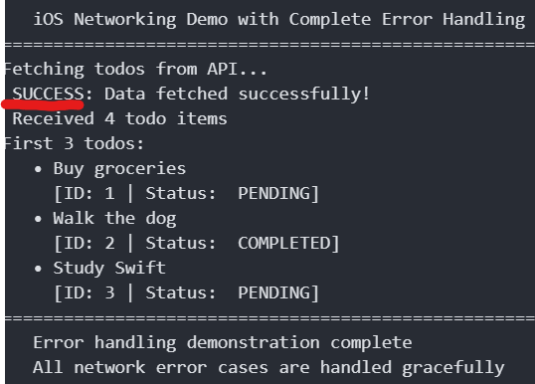

Output value to test: “noInternet”
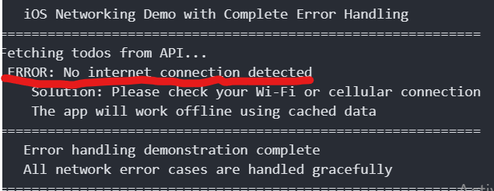
Output value to test: “noData”
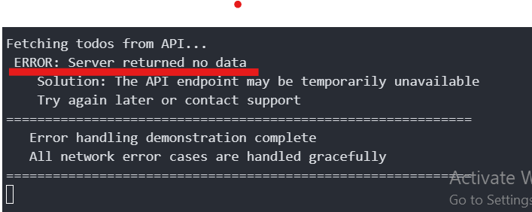
Output value to test: “invalidResponse”
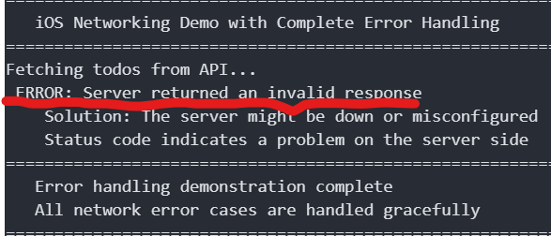

Output value to test: “decodingFailed”
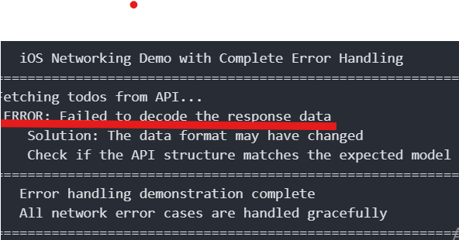
Explanation of the Error Handling Approach:
I created a new `NetworkError` enum that conforms to Swift's `Error` protocol for networking error handling. NoInternet, noData, invalidResponse, decodingFailed, and unknown are the five conditions in the enum. A completion handler with a Result<[Todo], NetworkError> type—a general enum that neatly expresses either success (with data) or failure (with a particular error)—is used by the fetchTodos method. Each fault condition is handled separately by the calling code using a switch statement, which offers user-friendly notifications and recommended fixes. This method highlights Swift's robust error handling capabilities, including generics (result type), exhaustive pattern matching, and enums with related values. The network call would use URLSession with async/await and try/catch in a real iOS app, but the error-handling logic would be the same.

